*Step 1: Identify Entities*

***Playlist:***

Attributes: playlist_url (primary key), year

***Track:***

Attributes: track_id (primary key), track_name, track_popularity, album, danceability, energy, key, loudness, mode, speechiness, acousticness, instrumentalness, liveness, valence, tempo, duration_ms, time_signature

Relationships:

Playlist (Associative Entity, Many-to-Many): A playlist contains multiple tracks, and a track can belong to multiple playlists.

Artist (Many-to-One): Each track is associated with one artist.

***Artist:***

Attributes: artist_id (primary key), artist_name, artist_genres, artist_popularity

*Step 2: Identify Relationships*

Playlist to Track (Associative Entity, Many-to-Many)

Track to Artist (Many-to-One)

*Step 3: Identify Cardinality and Ordinality*

Playlist to Track (Cardinality: Many, Ordinality: Many)

Track to Artist (Cardinality: Many, Ordinality: One)

Step 4: Add Attributes

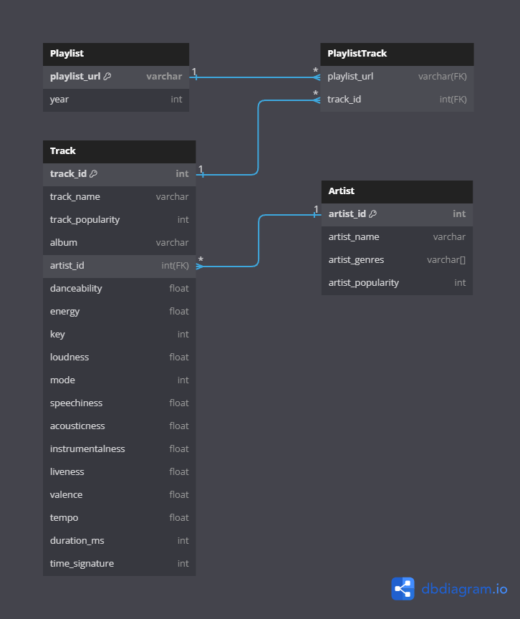

*Note: The associative entity PlaylistTrack is introduced for the Many-to-Many relationship between Playlist and Track.*